Chapter 10, Solution 62.

Using Thevenin's theorem, find v_{o} in the circuit in Fig. 10.105.

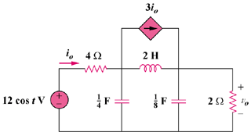

Figure 10.105
For Prob. 10.62.

Solution

First, we transform the circuit to the frequency domain.

(a)

I_{x}

j2

1 V

3 I_{o}
+

-j4

V_{x}

-j8

4

I_{o}

1

2
To find , consider the circuit in Fig. (a).
At node 1,
, where

Thus,
At node 2,

To find , consider the circuit in Fig. (b).

(b)

j2

3 I_{o}
+

-j4

V₁

-j8

4

I_{o}

1

2

120 V

V₂

+

V_{Thev}

At node 1,
, where
(1)
At node 2,
(2)

From (1) and (2),

,
Thus,

Therefore,
2.3cos(t–163.3) V

